G. Rupa Manasa 09-12-2023

Day 6 Assessment

**Database**

A database is a place to store information.

It can store the simplest data, such as a list of people as well as the most complex data.

The database stores the information in a well-structured format.

**Database Schema**

A database schema is a structure that represents the logical storage of the data in a database.

It represents the organization of data and provides information about the relationships between the tables in a given database.

It shows how the data is stored logically in the entire database.

It contains list of attributes and instruction that informs the database engine that how the data is organized and how the elements are related to each other.

A database schema contains schema objects that may include tables, fields, packages, views, relationships, primary key, foreign key.

The schema does not physically contain the data itself; instead, it gives information about the shape of data and how it can be related to other tables or models.

**Types of Database Schema**

The database schema is divided into three types, which are:

1. Logical Schema
2. Physical Schema
3. View Schema

**Physical Database Schema**

A physical database schema specifies how the data is stored physically on a storage system or disk storage in the form of Files and Indices.

Designing a database at the physical level is called a physical schema.

**Logical Database Schema**

The Logical database schema specifies all the logical constraints that need to be applied to the stored data.

It represents how the data is stored in the form of tables and how the attributes of a table are linked together.

At this level, programmers and administrators work, and the implementation of the data structure is hidden at this level.

Various tools are used to create a logical database schema, and these tools demonstrate the relationships between the component of your data. This process is called ER modelling.

The **ER modelling** stands for entity-relationship modelling, which specifies the relationships between different entities.

**View Schema**

The view level design of a database is known as view schema.

This schema generally describes the end-user interaction with the database systems.

**Database Instance**

It is a type of snapshot of an actual database as it existed at an instance of time. Hence it varies or can be changed as per the time.

Both instances and schemas are related to and impact each other through the DBMS.

DBMS ensures that every database instance complies with the constraints imposed by the database designers in the database schema.

**Creating Schema**

To create a schema, "CREATE SCHEMA" Statement is used.

In the SQL server, the "CREATE SCHEMA" statement creates a new schema with the name provided by the user.

**Database Schema Designs**

The following are the different designs of database schema.

Flat Model

Hierarchical Model

Network Model

Relational Model

Star Schema

Snowflake Schema

**Flat Model**

A flat model schema is a type of 2-D array in which each column contains the same type of data, and elements within a row are related to each other.

This schema design is most suitable for small applications that don't contain complex data.

**Hierarchical Model**

The Hierarchical model design contains a tree-like structure.

The tree structure contains the root node of data and its child nodes. Between each child node and parent node, there is a ***one-to-many relationship***.

This schema models are best suitable for storing the nested data, such as representing Hominoid classification.

**Network Model**

The network model design is similar to hierarchical design as it represents a series of nodes and vertices.

The main difference between the network model and the hierarchical model is that the network model allows a ***many-to-many relationship***.

It is best suitable for applications that require spatial calculations.

**Relational Model**

The relational models are used for the relational database, which stores data as relations of the table.

**Star Schema**

The star schema is a different way of schema design to organize the data.

It is best suitable for storing and analysing a huge amount of data.

With Star Schema, we can structure the data of RDBMS.

It works on "Facts" and "Dimensions".

**Snowflake Schema**

A snowflake schema is a multi-dimensional data model that is an extension of a star schema, where dimension tables are broken down into subdimensions.

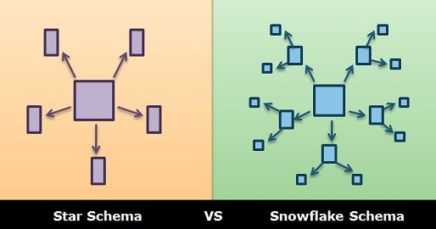

**Stored Procedure**

A stored procedure is a prepared SQL code that you can save, so the code can be reused over and over again.

* Creating Procedure and Executing the procedure.

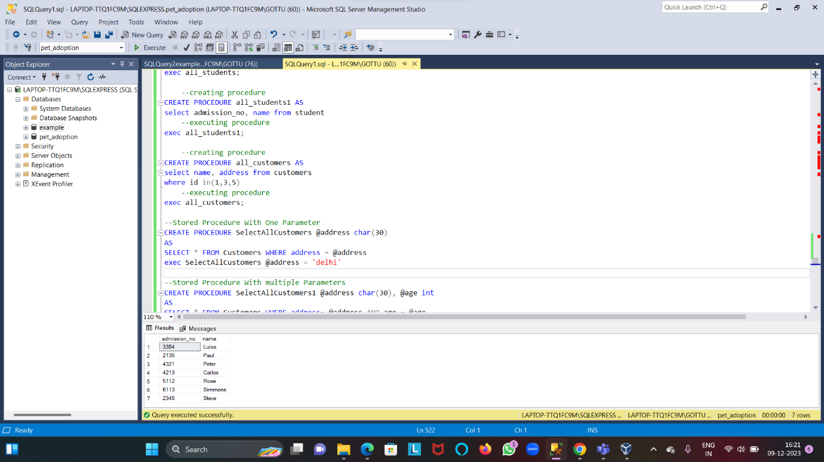

* **Stored procedure with One Parameter and Multiple Parameters**

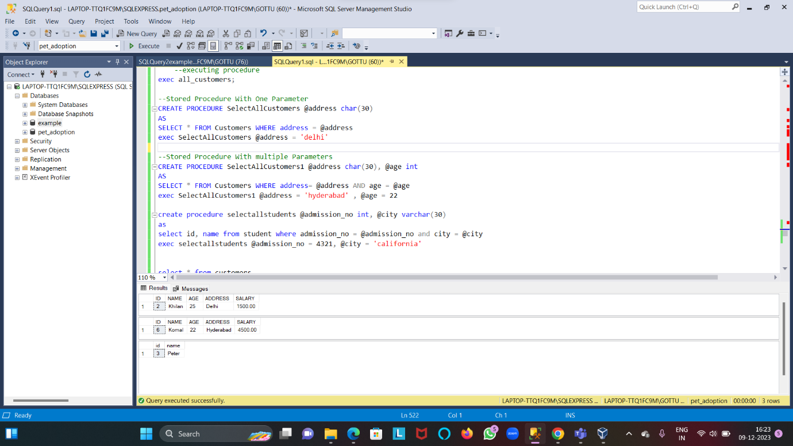

* **Calculating Sub totals and Totals**

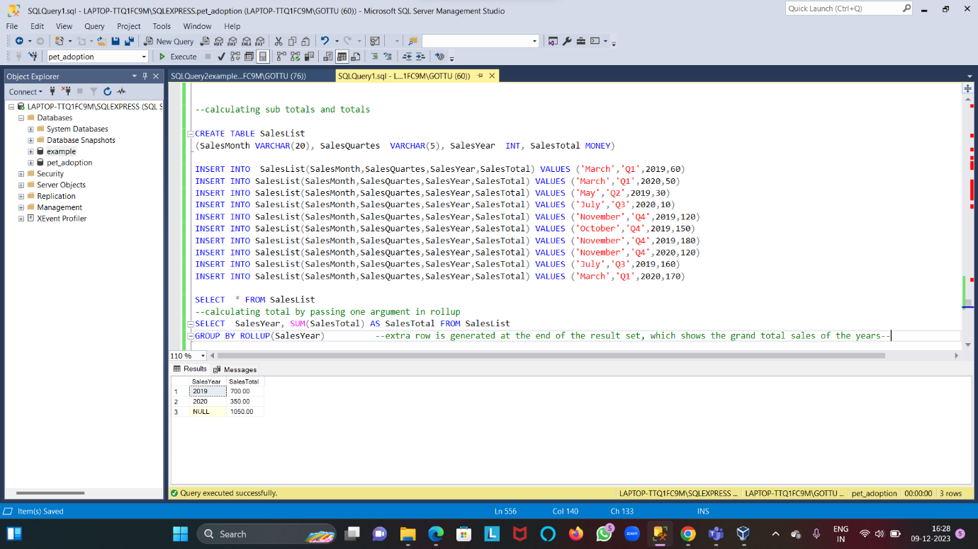

* **Calculating sub total and total by passing two and three arguments in Rollup**

